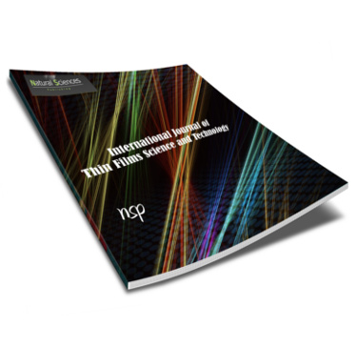  Sawsan Kara | Title: Statistical analysis of the impact of integrating students with special educational needs on their regular peers within the educational environment  Authors: Sawsan Kara, Nadia Ghalia, Mawaheb kheir Mustafa, HIYAM ABU REYA, Darawsheh Ahlam, 1 An educator Ministry of Education, Dalyat El Karmel, Israel, 3 An educator Ministry of Education, 4 An educator Ministry of Education and Sakhnin  We are very pleased to inform you that your article do meet the publication criteria and therefore has been accepted for publication in a forthcoming issue in  Journal of Statistics Applications & Probability  Please note that: we accepted only Latex submission so please send us the source files in Latex and the figures in Postscript, please use our journal Style files which can be obtained from the web    Yours sincerely,  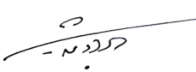
  Accepted: 22 July 2026
  Ref. 07222601A
  27 July 2026
S. Jing
For Editor-in-Chief
All submitted manuscripts, written in English, Arabic or French Language, are undergoing normal review process and the publication decision will be adjudged by quality, novelty, suitability and interest.
JSAP accepts papers through peer review by professional colleagues in the relevant fields. Unless clearly below the standard required by the journal, submitted articles will be sent to referees. They will generally be reviewed by at least two experts with the aim of reaching a decision as soon as possible. Plagiarism, or copying text or results from other sources, is unethical behavior and is not tolerated at this journal.
The journal focuses on traditional areas such as statistical inference, multivariate analysis, design of experiments, sampling theory, regression analysis, re-sampling methods, time series, nonparametric statistics, statistical tools, and analysis in human resources management, etc., and gives special emphasis to established as well as emerging applied areas such as
- Educational Technology,
- e-Learning, Management
- Media Management,
- Human Resources Management,
- Fine and Applied Arts,
- Humanities and Social Sciences,
- Hospitality and Tourism Research
- Educational Psychology
- Mental Health and Special Education
- Fundamentals of Education
- Educational Administration
- Special Education
- Curricula and teaching methods

